Дата: 29.05.2024 Клас: 5-Б

Предмет: Англійська мова

Тема: Урок узагальнення за ІІ семестр.

Мета: повторити вивчену лексику; повторити вживання дієслова “to be” у теперішньому часі; повторити питальні дієслова; розвивати мовну здогадку й мовленнєву реакцію учнів; виховувати зацікавленість у розширенні своїх знань.

Вчитель: Глуговська Л.Г.

Хід уроку

**1*.Greeting***

Good afternoon, dear children! I’m glad to see you. Are you ready to start our lesson? Let’s start.

***2.Warming up/ Listening***

***Watch the video “Happy Holiday”  
<https://www.youtube.com/watch?v=mYs5ClmpWnk>***

1. ***Speaking***

***Розподіліть слова по двом корзинам:***

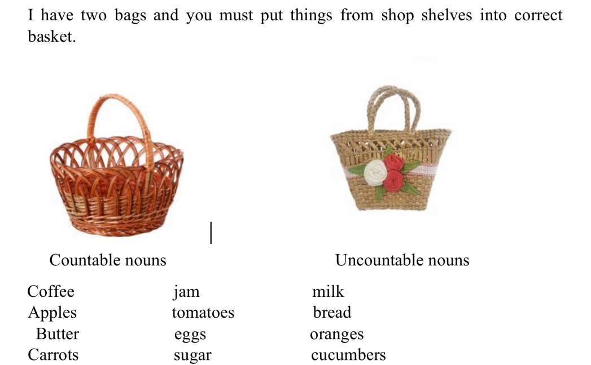

1. ***Reading***

***Прочитайте текст:***

***Lunch at School.***

Twelve o`clock is the time for lunch in our school. Children are running to the school cafe. They are thirsty and very hungry. Today they have some potatoes and some fish, a glass of tea and some biscuits for their lunch. There are also different kinds of burgers, pizzas and salads. Pupils can buy bottles of water, cans of lemonade or cartons of juice. My friend Pete likes to buy a bar of chocolate or a box of sweets. We like to have lunch at school.

1. ***Quiz***

Do the test.

**Test**

1. Children can have lunch at …

*a. School b. home c. work*

2. They have lunch at …

*a.12 o'clock b. 1 o'clock c. 2 o'clock*

3. The pupils … after the lessons.

*a. Go home b. do homework c. are hungry*

4. Today they have …

*a. Some potatoes and some fish*

*b. Some rice and some salad*

*c. Some porridge and some meat*

5. Pupils can buy …

*a. Flowers b. bottles of water c. some butter*

6. My friend Pete likes to buy…

*a. Oranges b. chocolate or sweets c. juice*

7. We like to have lunch at …

*a. Home b. the lesson c. School*

***6. Homework***

Домашнє завдання:

1. Опрацювати конспект, переглянути відео.